FORM 2

THE PATENTS ACT, 1970 (39 of 1970)

&

THE PATENTS RULES, 2003

COMPLETE SPECIFICATION

1. **TITLE OF THE INVENTION**

BillWise Pro: A Web-Based Solution for Streamlined Billing and Inventory Management in SMEs

**APPLICANT(S)**

|  |  |  |  |
| --- | --- | --- | --- |
| Name in Full | Nationality | Country of  Residence | Address of the Applicant |
| Mr. Akash Goel | Indian | India | KIET Group of Institutions  Delhi-NCR, Meerut Road (NH-58) Ghaziabad - 201206 |
| Mr. Dev Varshney | Indian | India | KIET Group of Institutions  Delhi-NCR, Meerut Road (NH-58) Ghaziabad - 201206 |
| Ms. Shreshthi Tayal | Indian | India | KIET Group of Institutions  Delhi-NCR, Meerut Road (NH-58) Ghaziabad - 201206 |
| Ms. Vanshika Jain | Indian | India | KIET Group of Institutions  Delhi-NCR, Meerut Road (NH-58) Ghaziabad - 201206 |
| Ms. Viyapi Tyagi | Indian | India | KIET Group of Institutions  Delhi-NCR, Meerut Road (NH-58) Ghaziabad - 201206 |

1. **PREAMBLE TO DESCRIPTION**

COMPLETE SPECIFICATION -

The following specification particularly describes the invention and the manner in which it is to be performed.

**Title:**

BillWise Pro: A Web-Based Solution for Streamlined Billing and Inventory Management in SMEs

# Field of the Invention

**[0001]**

The present invention relates to a comprehensive web-based billing and inventory management system tailored for small and medium-sized enterprises (SMEs). Specifically, it integrates secure user authentication, dynamic notifications, and real-time dashboards for streamlined operations and enhanced decision-making.

**Background**

**[0002]** With SMEs increasingly adopting digital tools for efficiency, there is a growing reliance on platforms to manage billing and inventory processes. Current systems often lack accessibility or affordability, creating operational bottlenecks.

**[0003]** Manual methods for handling invoices and inventory lead to errors, delays, and inefficiencies, especially as businesses grow. Errors in stock tracking and invoice generation can result in financial losses and strained customer relationships.

**[0004]** While enterprise-grade ERP systems address such inefficiencies, they are expensive, difficult to implement, and often unnecessary for smaller businesses with simpler workflows.

**[0005]** Standalone software solutions for billing or inventory fail to provide an integrated ecosystem. Without synchronization, SMEs must rely on multiple platforms, which increases complexity and decreases operational cohesion.

**[0006]** There is a lack of systems designed for SMEs that focus on secure, real-time operations. Most solutions are either fragmented or have high entry costs, making them unsuitable for smaller businesses.

**[0007]** BillWise Pro introduces a comprehensive, web-based system that integrates billing, inventory tracking, and customer management. It is designed to automate repetitive tasks, improve accuracy, and provide a scalable, user-friendly experience.

**Summary of the Invention**

**[0008]** **OTP-Based Secure Login**: Ensures secure, authorized access to the platform.

**[0009]** **Dynamic Notifications**: Alerts for overdue payments, low stock levels, and other critical actions.

**[0010] Real-Time Dashboards**: Provides visual insights into key metrics such as inventory, sales, and pending payments.

**[0011] Automated Workflows**: Simplifies invoice generation, payment records, and inventory adjustments.

**[0012]** The system reduces reliance on manual processes, providing SMEs with a reliable and easy-to-use platform to manage their daily operations effectively.

**Objects of the Invention**

**[0013]** The primary objective is to create a web-based platform that consolidates billing and inventory management processes into a single interface.

**[0014]** Another objective is to provide real-time insights and automated alerts to improve decision-making and operational responsiveness.

**[0015]** A further goal is to ensure affordability and scalability, enabling SMEs to grow with minimal technical overhead.

**Advantages of the Invention**

**[0016]** Reduces manual errors by automating billing and inventory management processes.

**[0017]** Improves decision-making with real-time dashboards and actionable insights.

**[0018]** Enhances operational efficiency through secure, dynamic notifications and workflows.

**[0019]** Scales with business growth, thanks to its modular design.

**[0020]** Provides an affordable alternative to expensive ERP systems, specifically catering to SMEs.

# Drawings

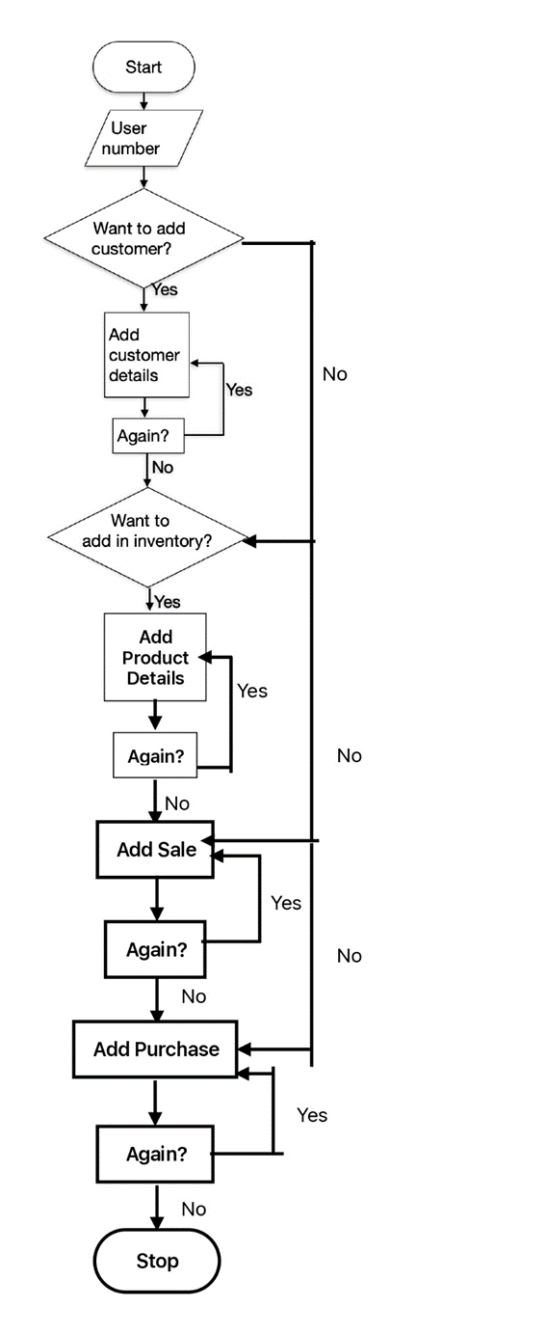

# Figure 1

# Brief Description of the Drawing

**[0021]** **Figure 1** represents the workflow of **BillWise Pro**, showcasing its systematic approach to billing and inventory management. It begins with secure user authentication using OTP login, followed by customer data management. Users can then proceed to manage inventory by adding or updating product details. The workflow includes generating sales records and invoices, with options to add more entries as needed. Finally, purchase management allows tracking expenses and inventory adjustments, ensuring an efficient and user-friendly process for SMEs.

# Detailed Description of The Invention

**[0022] System Overview**: BillWise Pro operates as a web-based application, ensuring scalability and seamless operation across devices. The system is built with modern web technologies, ensuring speed, security, and reliability.

**[0023] Authentication Module**: OTP-based login ensures secure user access. This mechanism minimizes unauthorized entry risks, protecting sensitive business data.

**[0024]** **Dashboard Visualization**: The platform features an interactive dashboard built with React and Tailwind CSS. Key metrics, including sales, inventory levels, and overdue payments, are displayed in real-time.

**[0025] Billing Automation**: Automated workflows handle invoice generation, updates, and tracking of payment statuses. The system reduces manual intervention, ensuring consistency and reliability.

**[0026] Inventory Tracking**: A robust inventory module automatically updates stock levels after each transaction. Alerts are generated for low-stock conditions to prompt timely replenishment.

**[0027] Dynamic Notifications**: Real-time notifications via Toastify inform users about critical events, such as overdue payments or low stock, ensuring timely action.

**[0028] Backend Architecture**: Powered by Express.js and Node.js, the backend ensures efficient processing of API requests, supporting smooth communication between modules.

**[0029] Database Design**: PostGreSQL is used for data storage, enabling relational management of billing, inventory, and customer records. Indexed schemas improve query performance.

**[0030] Scalability**: The system is designed with modularity in mind, allowing for feature expansion and integration with third-party tools.

**[0031] Data Reporting**: Generates comprehensive financial and inventory reports, providing users with actionable insights to optimize business performance.

**[0032] User Experience**: The interface prioritizes simplicity, ensuring ease of use for non-technical users.

**[0033]** **Energy Efficiency**: Optimized for low computational resource consumption, making it suitable for devices with limited processing power.

**[0034] Continuous Improvement**: Agile methodologies ensure regular updates based on user feedback, improving platform performance over time.

# Claims

# We Claim:

1. A web-based platform integrating billing and inventory management, featuring secure OTP-based login and real-time dashboards.
2. The system in claim 1, wherein dynamic notifications alert users to overdue payments, low inventory, and system updates.
3. A method for automating billing workflows, comprising invoice generation, payment tracking, and customer management.
4. The system as claimed in claim 1, wherein inventory tracking is automated, providing alerts for low-stock conditions and critical actions.

# Abstract

The invention presents **BillWise Pro**, a web-based platform aimed at simplifying billing and inventory management for SMEs. It features secure OTP-based login, dynamic notifications, and real-time dashboards for actionable insights. The system automates repetitive tasks, such as invoice generation and inventory tracking, while providing comprehensive data visualization. Its scalable, modular architecture allows customization and integration with external systems like payment gateways. BillWise Pro offers an affordable, streamlined solution to enhance operational efficiency and data accuracy, empowering SMEs to focus on growth and innovation.



Date: Mr. Dev Varshney et. al.

22 / 11 / 24